Module 12 : Custom Charts

1. Pareto Chart: Create a Pareto Chart to show what percentage of products (use product id) sold by Superstore contribute to 80% of its sales.

Sample Screenshot of Output:

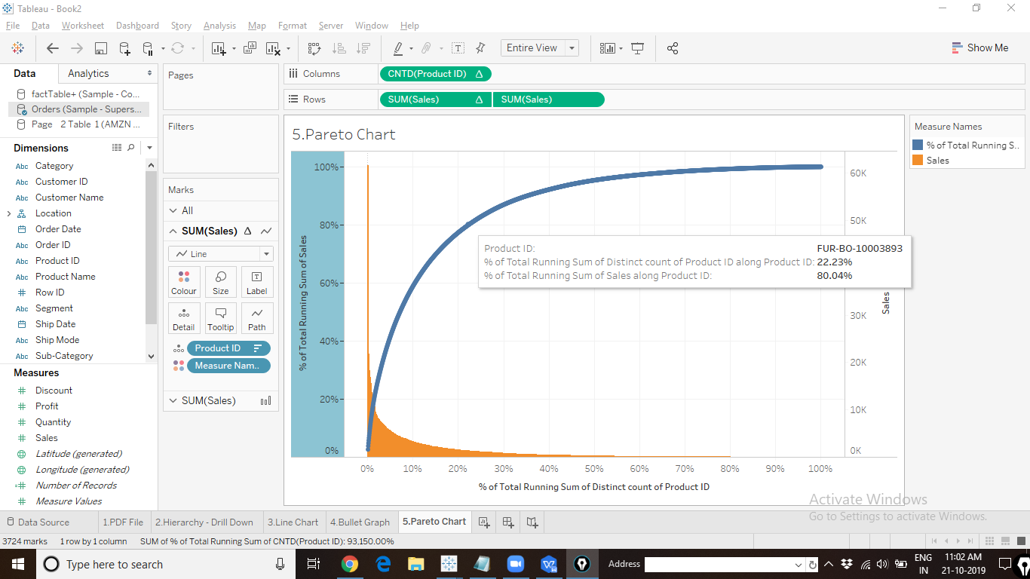

1. Waterfall Chart: With the help of Waterfall chart show how sales start, end and get incremented over a period of time.

Sample Screenshot of Output:

